Leaf Disk Photosynthesis
(adapted from Brad Williamson’s Leaf Disk Lab by Sara McCarthy at http://web.me.com/wypixievicks/I_LOVE_science!/Teachers_Area.html)
Introduction

Light is a part of a continuum of radiation, or energy waves. Shorter wavelengths of energy have greater amounts of energy. For example, high-energy ultraviolet rays can harm living tissues. Wavelengths of light within the visible part of the light spectrum power photosynthesis.

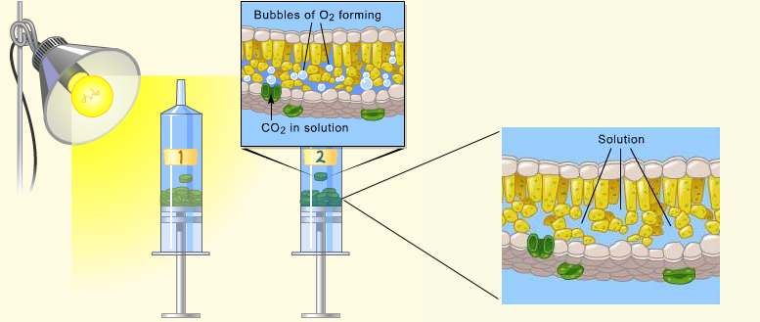
When light is absorbed by leaf pigments, electrons within each photosystem are boosted to a higher energy level, and this energy is used to produce ATP and to reduce NADP to NADPH and then used to incorporate CO2 into organic molecules, a process called carbon fixation.

Leaf disks float, normally. When the air spaces are infiltrated with solution the overall density of the leaf disk increases and the disk sinks. The infiltration solution includes a small amount of sodium bicarbonate. The bicarbonate ion serves as the carbon source for photosynthesis. As photosynthesis proceeds oxygen is released into the interior of the leaf which changes the buoyancy- causing the disks to rise. Since cellular respiration is taking place at the same time, consuming oxygen, the rate that the disks rise is an indirect measurement of the net rate of photosynthesis.

Materials

Procedure

- Label 4 cups with the following: 30 cm CO2 Light, CO2 dark, Water/soap Light, 50 cm CO2 Light
- Mix 1/8t of baking soda and mix it in 300 ml of water in one of the beakers provided. (fig 1)
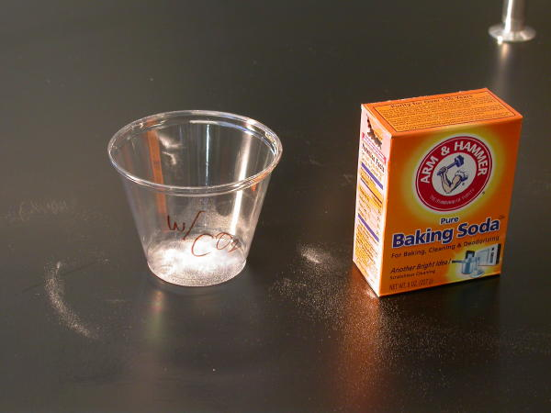
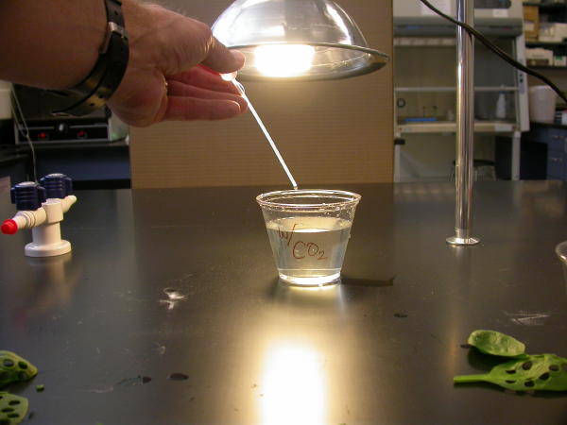
- Add a squirt of soap to the beaker and add 200mL of water.
Fig. 1

Sodium Bicarbonate (baking soda) | Timer
Liquid soap | Light Source
Plastic Syringe (10cc or larger) | Hole Punch
Leaves | 2 Small Beakers
4 Plastic cups | Plastic pipette

Fig. 2

- Using the plastic pipette, add one drop of the dilute liquid soap to the baking soda solution. Avoid suds. If your solution generates suds, dilute it with more bicarbonate. (Fig. 2)
- Hole punch 10 uniform leaf disks for each trial using the hole punch. Avoid the major veins in the leaf (fig. 3)
- Remove the plunger of the syringe and place your leaf disks in the syringe barrel.
- Replace the plunger, being careful not to crush the leaf disks. Push on the plunger until only a small volume of air and leaf disk remain in the barrel. (fig. 4)
- Put a small volume of sodium bicarbonate solution into the syringe. Tap the syringe to suspend the leaf disks in the solution.
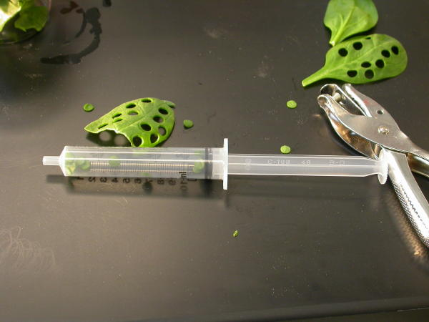
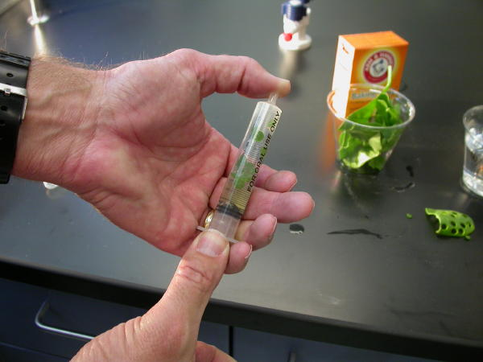
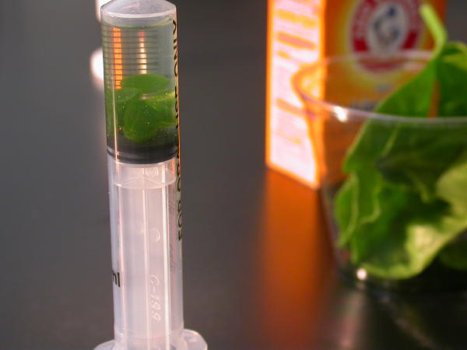
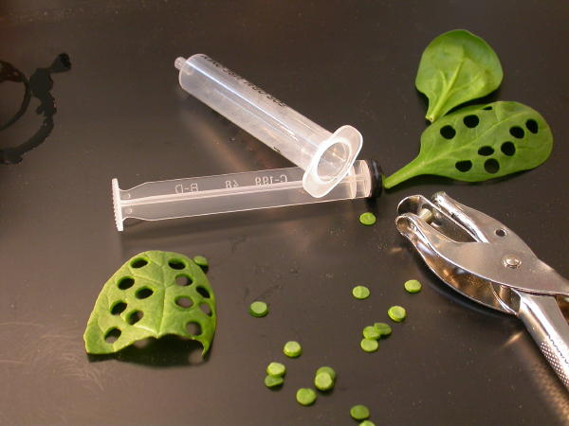
- Hold a finger over the syringe opening, draw back on the plunger to create a vacuum. Hold this for 10 seconds. (fig. 5)
Fig. 4

Fig. 5

Fig. 6

Fig. 3

- While holding the vacuum, swirl the leaf disks to suspend them in solution.
- Let off the vacuum.
- If you need to, repeat the vacuum steps 2-3 times more, until all of the disks sink. (fig. 6)
- If the disks still don’t sink, add more soap to the solution and repeat steps 6-12.
- Pour the disks and the solution into the correct cup.
- Add the bicarbonate solution until the cup is 3/4 full.

- Place under light that is located about 30 cm away and begin timing (fig. 7).
- Record how many disks are floating at the end of each minute in the table below.
- Then gently swirl the disks with the pipette to dislodge any that are stuck to each other or the sides of the cup.
- Repeat 17 and 18 until ALL of the disks are floating. (Fig. 8)
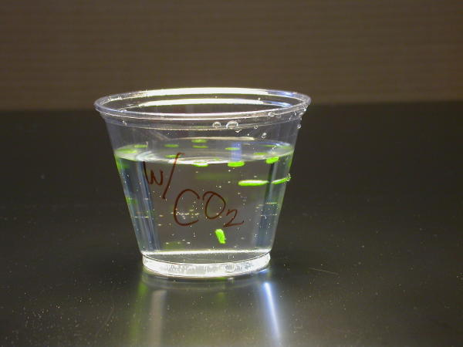
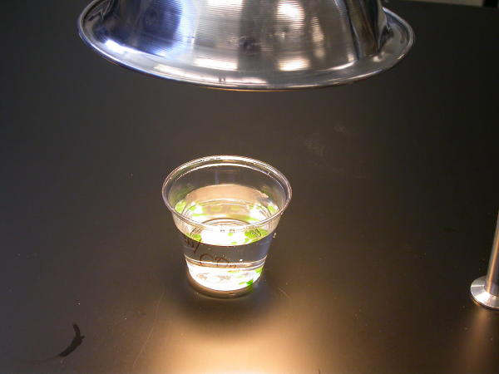
- Repeat with water/soap under the light except replace the bicarbonate solution with the diluted soap in the plunger.
Fig. 8

Fig. 7

- Repeat with the light at 50 cm away.
- For the dark, follow all steps and keep the cup under the light for 14 minutes, counting the disks every minute. At 14 minutes, shut off the light and place the disks in the dark.
- Every minute, count how many disks are still floating until all the disks have sunk or you have reached 30 min.
- Gently swirl the disks with the pipette.
- Graph your results on the graph provided.

Data and Analysis
Minutes | # of leaf disks floating
1
2
3
4
5
6
7
8
9
10
11
12
13
14
15

30 cm Light CO2

Minutes | # of leaf disks floating | Minutes | # of leaf disks floating
1 |  | 16
2 |  | 17
3 |  | 18
4 |  | 19
5 |  | 20
6 |  | 21
7 |  | 22
8 |  | 23
9 |  | 24
10 |  | 25
11 |  | 26
12 |  | 27
13 |  | 28
14 |  | 29
15 |  | 30

Dark CO2

Minutes | # of leaf disks floating
1
2
3
4
5
6
7
8
9
10
11
12
13
14
15

Minutes | # of leaf disks floating
1
2
3
4
5
6
7
8
9
10
11
12
13
14
15

50 cm Light CO2

Water/Soap Light

Questions:

- What was the function of the sodium bicarbonate in this experiment?
- ________________________________________________________________________________________________________________________________________________________________________________________________________________________________________________________________________________________________
- ________________________________________________________________________
- Explain the process of carbon fixation.
- ________________________________________________________________________________________________________________________________________________________________________________________________________________________________________________________________________________________________
- ________________________________________________________________________
- Explain the process that causes the leaf disks to rise.
- ________________________________________________________________________________________________________________________________________________________________________________________________________________________________________________________________________________________________
- ________________________________________________________________________
- Which trial worked the best? Explain.
- ________________________________________________________________________________________________________________________________________________________________________________________________________________________________________________________________________________________________
- ________________________________________________________________________
- What was the purpose of using water/soap solution for one of the trials?
- ________________________________________________________________________________________________________________________________________________________________________________________________________________________________________________________________________________________________
- ________________________________________________________________________
- What is the effect of darkness on photosynthesis? Explain.
- ________________________________________________________________________________________________________________________________________________________________________________________________________________________________________________________________________________________________
- ________________________________________________________________________
- If we were to boil the leaf disks, what kind of results would you expect? Explain.
- ________________________________________________________________________________________________________________________________________________________________________________________________________________________________________________________________________________________________________________________________________________________________________
- How does light intensity affect the rate of photosynthesis?________________________________________________________________________________________________________________________________________________________________________________________________________________________________________________________________________________________________________________________________________________________________________
- How does light intensity and the rate of photosynthesis relate to the position of the sun, both during the day and during the year?
- ________________________________________________________________________________________________________________________________________________________________________________________________________________________________________________________________________________________________________________________________________________________________________

- Design an experiment using the same set up to investigate a different variable in the rate of a photosynthesis. Make sure that you explain how you would collect your data and why you chose this variable to test. Make sure you do this part well. I may ask you to actually perform it for me in the coming days.
- ________________________________________________________________________________________________________________________________________________________________________________________________________________________________________________________________________________________________________________________________________________________________________
- ________________________________________________________________________________________________________________________________________________________________________________________________________________________________________________________________________________________________________________________________________________________________________
- ________________________________________________________________________________________________________________________________________________________________________________________________________________________________________________________________________________________________________________________________________________________________________
- ________________________________________________________________________________________________________________________________________________________________________________________________________________________________________________________________________________________________________________________________________________________________________
- ________________________________________________________________________________________________________________________________________________________________________________________________________________________________________________________________________________________________________________________________________________________________________
- ________________________________________________________________________________________________________________________________________________________________________________________________________________________
- ________________________________________________________________________________________________________________________________________________________________________________________________________________________________________________________________________________________________________________________________________________________________________
- ________________________________________________________________________________________________________________________________________________________________________________________________________________________________________________________________________________________________________________________________________________________________________
- ________________________________________________________________________________________________________________________________________________________________________________________________________________________________________________________________________________________________________________________________________________________________________
- ________________________________________________________________________________________________________________________________________________________________________________________________________________________________________________________________________________________________________________________________________________________________________
- ________________________________________________________________________________________________________________________________________________________________________________________________________________________________________________________________________________________________________________________________________________________________________
- ________________________________________________________________________________________________________________________________________________________________________________________________________________________________________________________________________________________________________________________________________________________________________

